**NIT3222 – Virtualisation in Computing**

**Lab 2**

***ID: s4650134 Name: _FangSen(Wirth)___ _________***

This lab will use ISO images found in ‘C:\Lab Software-2012\Images\’.

1. Ensure that the server has the correct configuration

Essentially this means that the Hyper-V has been installed on the server.

1. Install operating systems
   1. Install Windows Server 2012 R2

The install file begins with ‘9600.17050.WINBLUE_REFRESH'.

* + 1. Select New then Virtual Machine from the actions menu

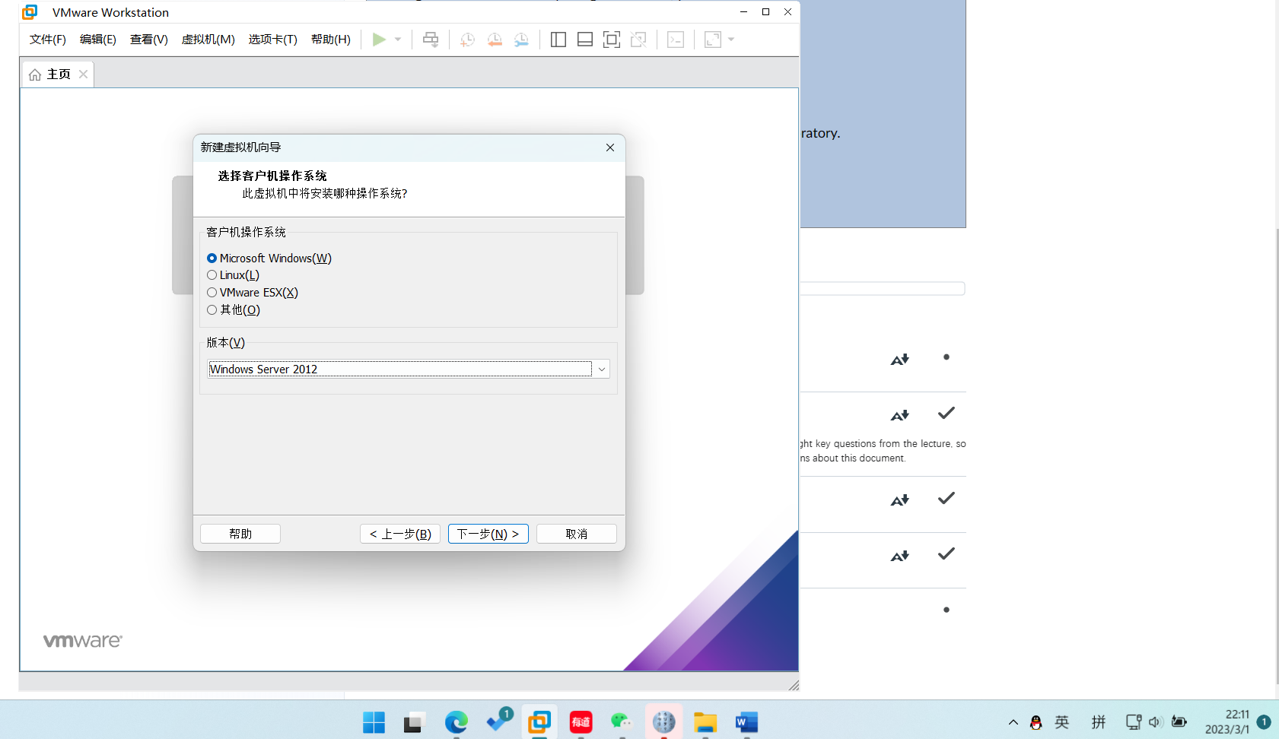

* + 1. Name the VM ‘Win2012R2’ and store it in the default location
    2. Select Generation 1 for the generation of the virtual machine

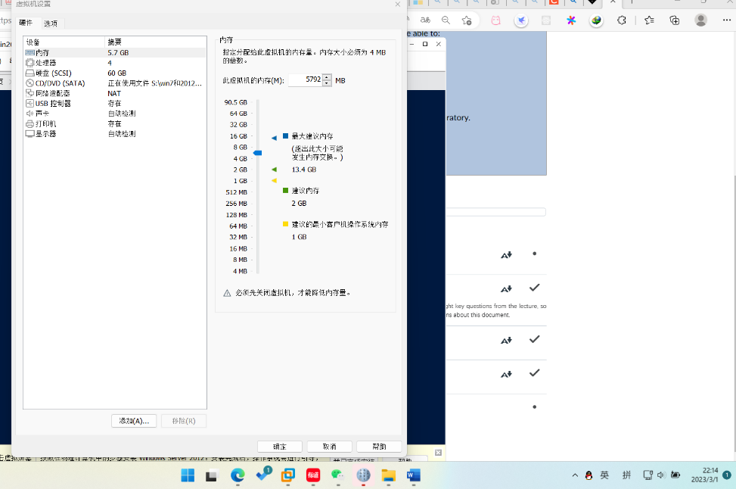

* + 1. Set the memory to be 4096 MB
    2. Leave the machine disconnected from the network
    3. Create a new VHD of 30GB in size
    4. Finish the wizard with install an operating system later
    5. Select the Windows 2012 R2 install file by selecting Media then DVD Drive then Insert disk

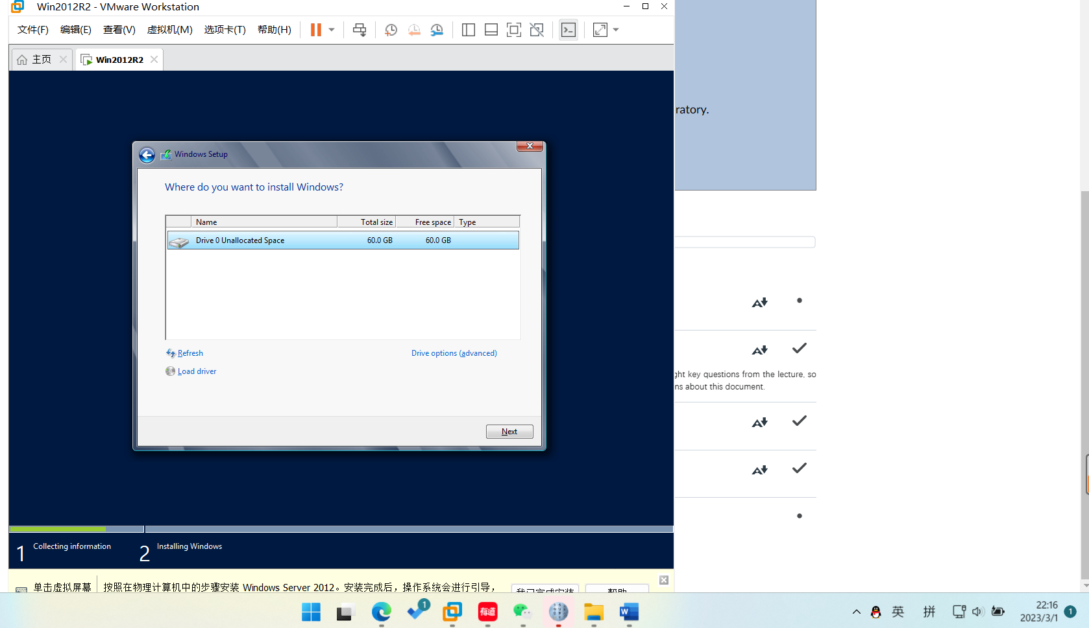

* + 1. Navigate to where the install file is stored and select it
    2. Proceed with the installation of the standard installation (Server with a GUI)

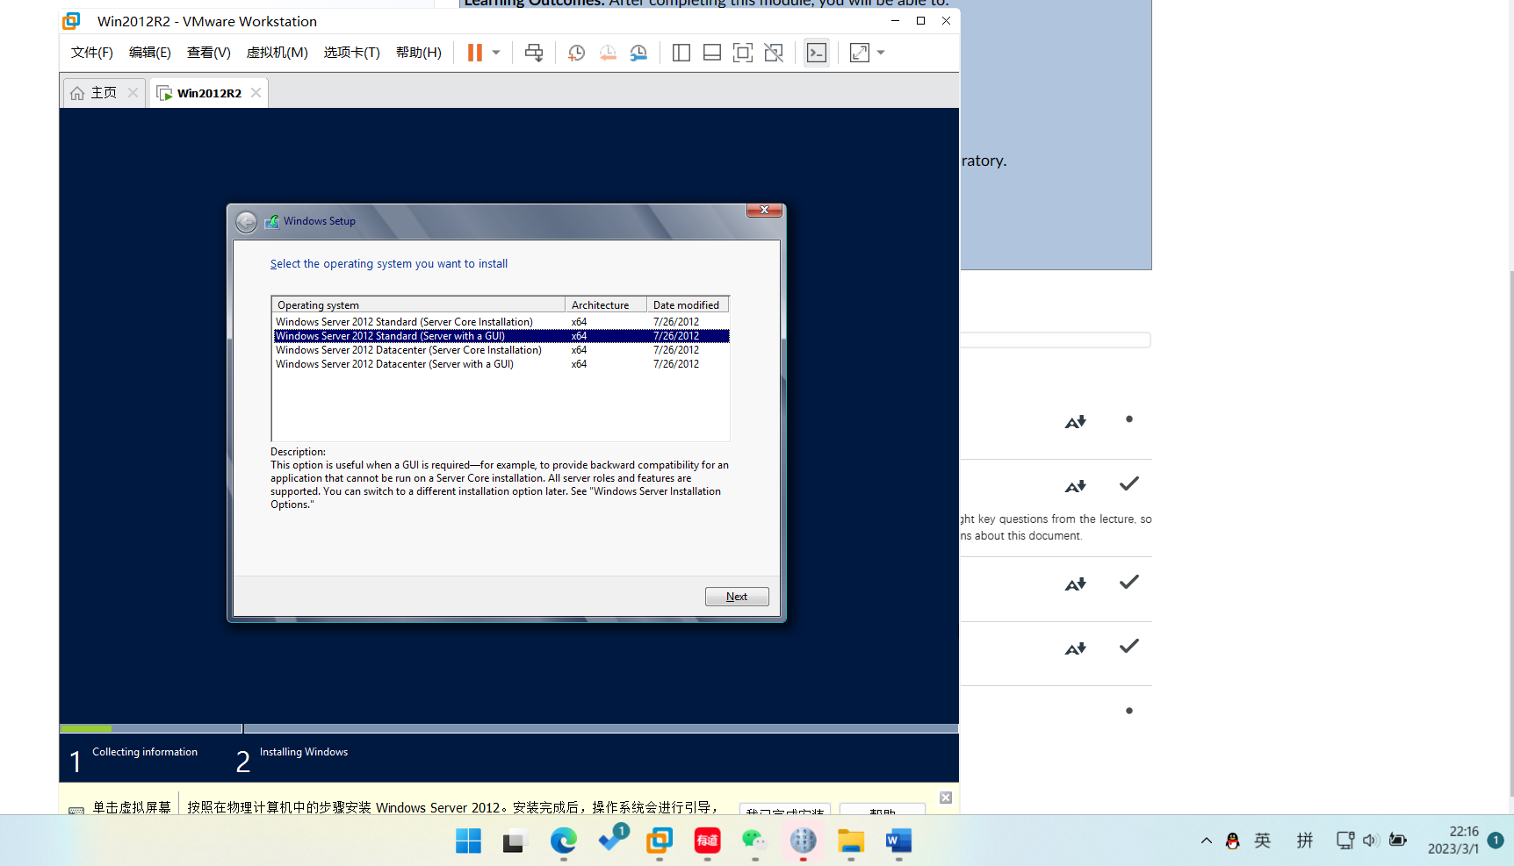

* 1. Install Windows 7

The install file begins with ‘win7 32bits’.

* + 1. Select New then Virtual Machine from the actions menu
    2. Name the VM ‘Win7’ and store it in the default location

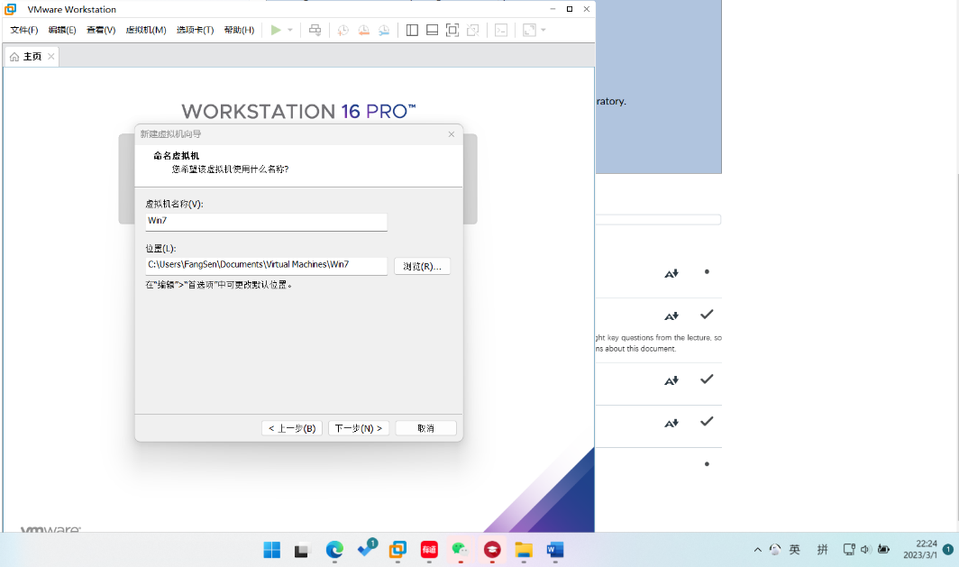

* + 1. Select Generation 1 for the generation of the virtual machine
    2. Set the memory to be 512 MB

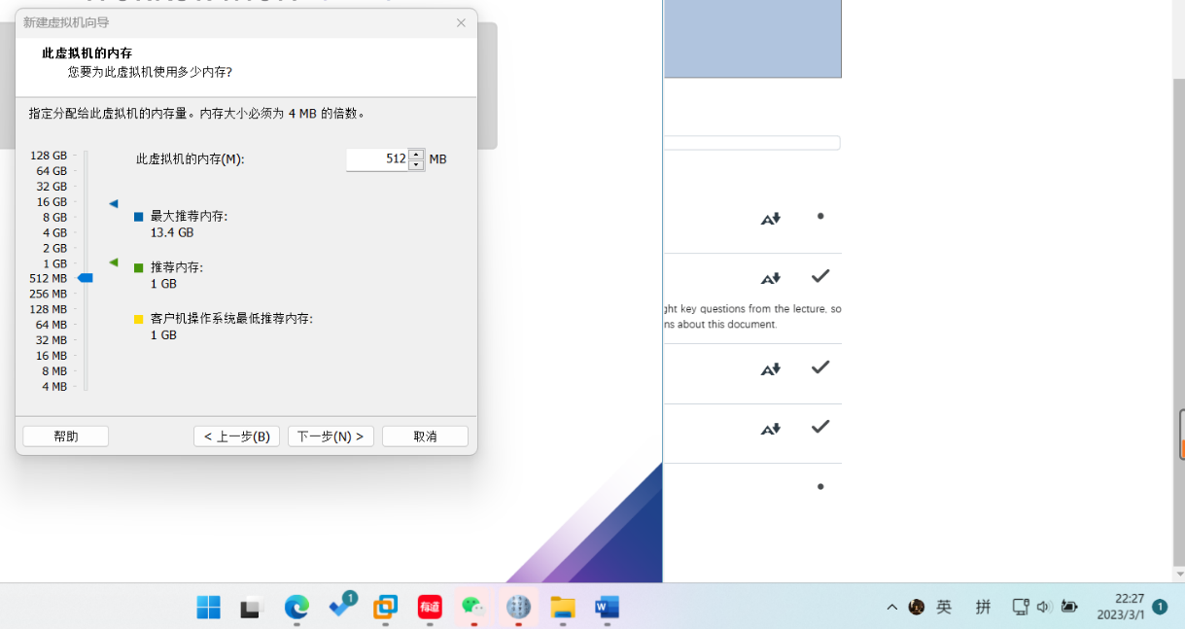

* + 1. Leave the machine disconnected from the network
    2. Create a new VHD of 15GB in size

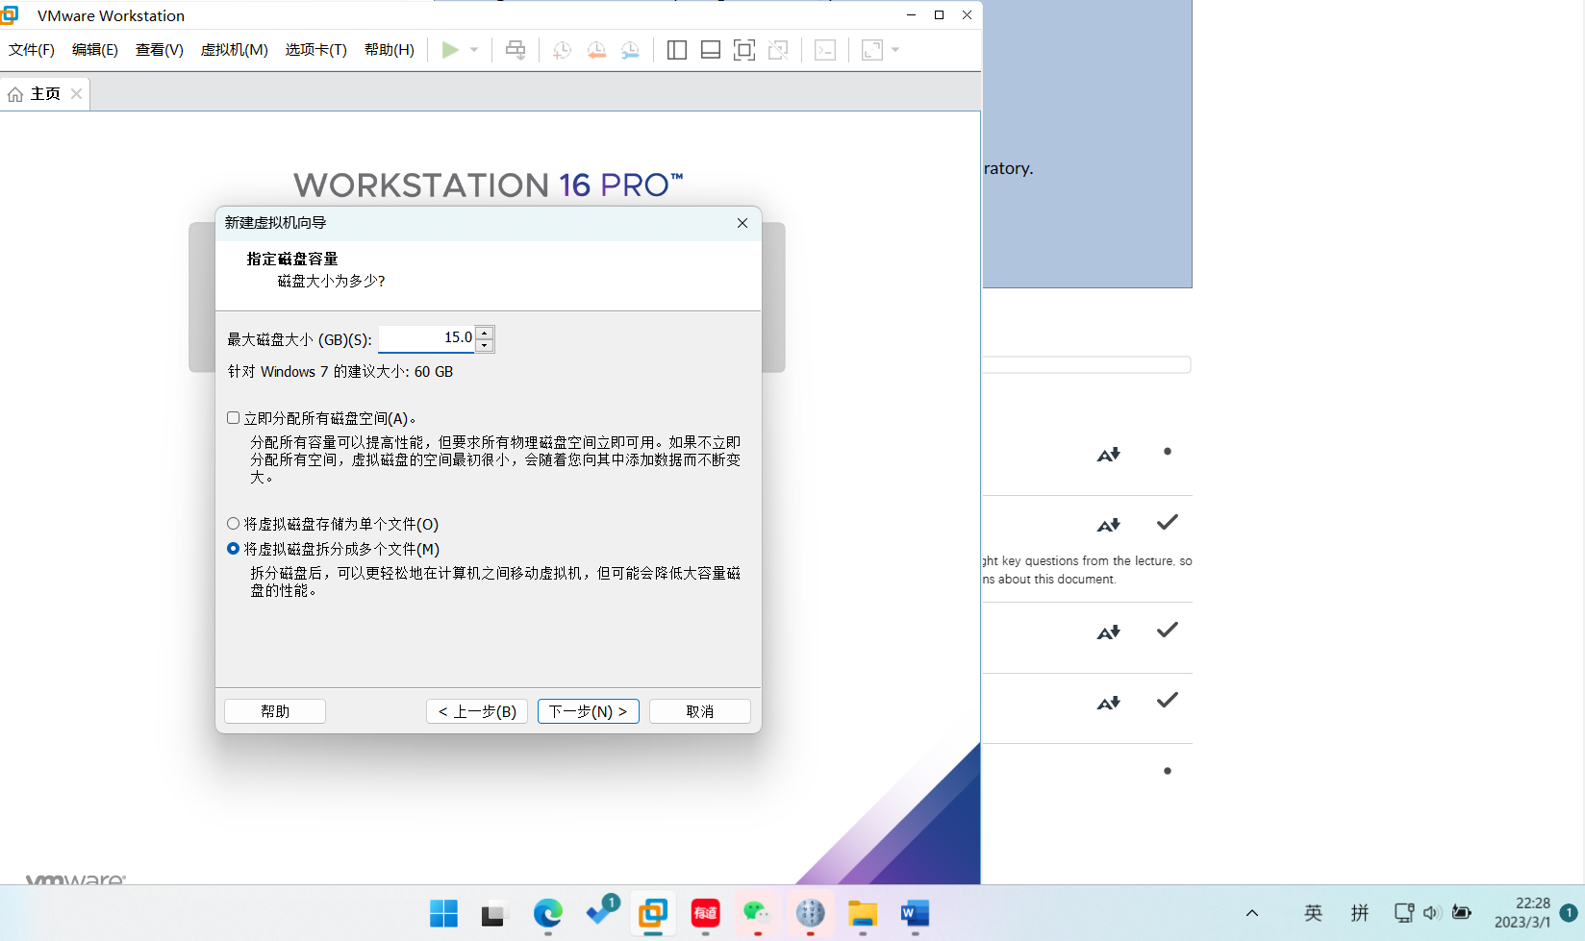

* + 1. Finish the wizard with install an operating system later
    2. Select the Windows 7 install file by selecting Media then DVD Drive then Insert disk

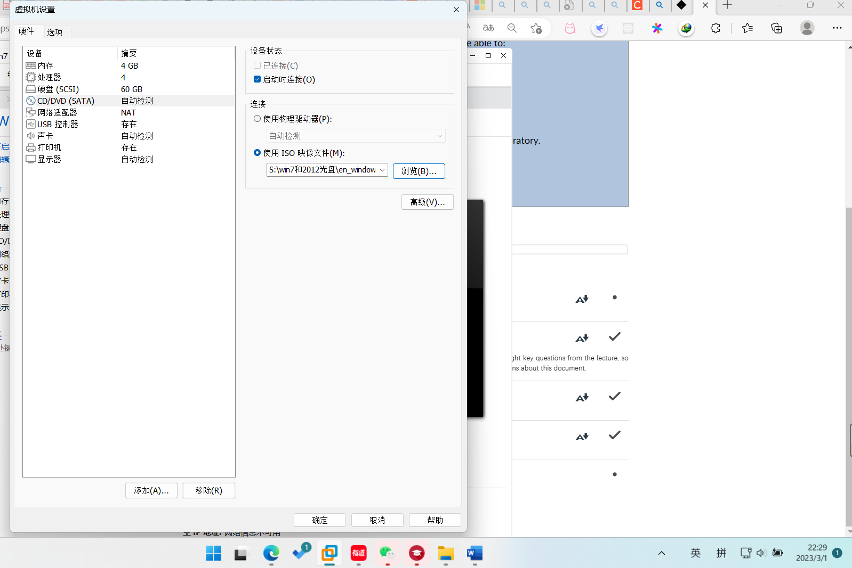

* + 1. Navigate to where the install file is stored and select it
    2. Proceed with the standard installation of the operating system

Upon completion, demonstrate to the lecturer you have successfully installed the operating systems.

